**Subcommittee Report on Grand Challenge: Protecting our Environment**

**Subcommittee Members:** Astrid Volder, Jacqueline Aitkenhead-Peterson, Spencer Behmer, Thomas Lacher, Clyde Munster, Richard Woodward, Joshua Yuan. **Facilitator:** David Reed

**Introduction**

From preserving biodiversity to sustainable stewardship of land and water resources in the face of global change, the College of Agriculture and Life Sciences at Texas A&M University is dedicated to protecting our environment. The college takes a leadership role in protecting our environment by leading the nation in research into the functioning of ecosystems altered by humans, either through urbanization or agriculture, and those (semi) natural systems threatened by climatic change and other anthropogenic change. Our faculty and students will lead the way in improving our understanding of ecosystem functioning and developing sustainable solutions to changes in land use and adaptation to global change. Global change is a pressing and truly global problem and affects the climate, carbon cycle, nutrient and water cycles and all other processes depending on these cycles. Global change occurs largely due to the impacts of agriculture and urban pressures on natural ecosystems. We are moving into a new era where improved management of existing agricultural landscapes is critical to protection of our environment. Forefront issues are soil degradation and loss, nutrient pollution from fertilizers and animal waste, and water consumption, as well as their effects on ecosystems services and biodiversity. Many of these same issues exist in urban environments, too, where air and water pollution and runoff from impervious surfaces harm stream health and impact water supplies. We will need to develop strategies to project the rate and magnitude of global change and its ensuing impacts and then develop tactics to adapt, or better, mitigate the causes of global change.

**Focus Areas:**

Within this grand challenge area, the sub-committee members identified five foci for this initiative, all can be placed under an overarching theme of “Climate and Land Use Change” in urban, natural and agricultural settings (Figure 1). The five foci are: (1) *Climate change/global change,* (2) *Water,* (3) *Urbanization,* (4) *Invasive species,* and (5) *Biodiversity*. A brief description of each is provided below.

***(1) Climate Change/Global Change***

At very broad scales, climate change is expected to alter species distributions, cause more frequent weather-related disturbance events, shift rainfall patterns that drive water supplies and stream hydrographs, and accelerate sea level rise that will lead to issues with saltwater intrusion and coastal flooding. Changes in seasonal precipitation patterns, annual rainfall amounts and rising temperatures will significantly impact agriculture and the humans depending on it. Both seasonal rainfall and temperature patterns are predicted to become more variable with a higher incidence of extreme rainfall events as well as more prolonged drought periods, coupled with a greater incidence of regionally extreme high temperatures. How changes in climate and climatic stability will affect crop productivity (food security) and ecosystem services (e.g., nutrient cycling, climate mitigation, pollination) will be topics of increasing importance when designing sustainable solutions to support the future world population.

One major driver of global change is land use change. Land use change, which includes conversion of natural lands to cropland, urban, and peri-urban regions has a detrimental effect on ecosystem services, biodiversity and the movement of species and is a major contributor to CO2 release into the atmosphere. Estimates suggest that land use change contributes a net 1.6 Gt carbon per year to the atmosphere. Habitat loss, ecosystem degradation, and fragmentation affect carbon, water and nutrient cycling, have devastating effects on biodiversity, and are the greatest cause of extinction of terrestrial species. Thus, the committee identified land use change as another major area under the global change umbrella which will be important for the next decades.

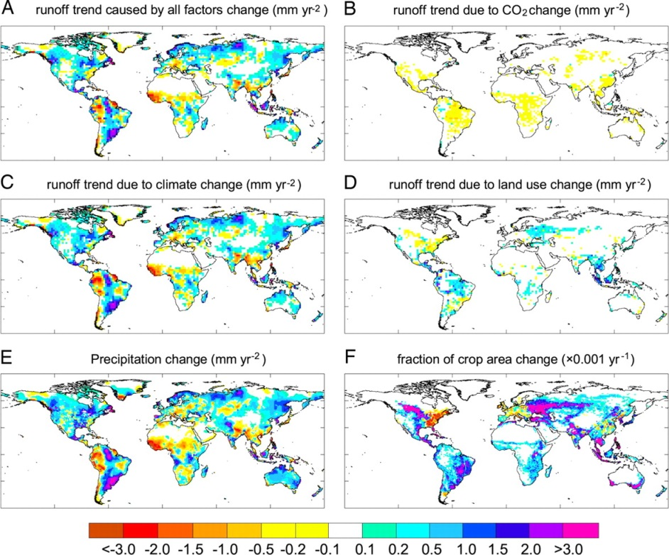

*Figure 1.* Combined effects of climate change and land use change on global river runoff (Piao et al., 2007. PNAS 104: 15242-15247).

***(2) Water***

In a comprehensive report, the US Defense Intelligence Agency concluded that access to high quality fresh water is not just an agricultural or human health issue, but a major peace and security issue (ICA 2012-08). Lack of available water will lead to major food insecurity as the world population increases along it exponential track and exerts pressure on precious water resources. The FAO estimates that in a world without climate change an 11% increase in irrigation water usage by 2050 would be necessary to support the estimated 9 billion people at that time (FAO Report 36, 2011). By 2025, 1.8 billion people are expected to be living in countries or regions with “absolute” water scarcity (<500 m3 per year per capita), and two-thirds of the world population could be under “stress” conditions. Climate change will impact the extent and productivity of both irrigated and rain fed agriculture across the globe. Reductions in river runoff and aquifer recharge will affect water availability in regions that are already water-stressed while highly populated deltas are at risk from a combination of reduced inflows, increased salinity and rising sea levels. Everywhere, rising temperatures will translate into increased crop water demand. Food security of a predominantly urban population is at risk from water-related impacts linked primarily to climate variability. Pollution of potable water sources by sewage, pesticides, fertilizer runoff and other anthropogenic contaminants further threatens access to safe drinking water. Adapting to global change can be an opportunity for change, providing impetus for developing cultivation methods and cultivars that improve resource use efficiency as well as the development of best management practices to reduce point and non-point sources of pollutants.



*Figure 2.* Main agricultural zones where climate change will impact water resources (FAO, 2011)

***(3)Urbanization***

The world urban population is expected to increase by 72% from 3.6 billion in 2011 to 6.3 billion in 2050 (UN 2011) compared to a total population increase from 7 billion in 2011 to 9.3 billion in 2050 (33% increase). Most of this growth will be in mega cities (>10 million inhabitants). Issues of food security may become even more important for people living in these urban areas, particularly those cities located in developing countries. Conversion of farmland and wild lands to urban land increase conflicts between urban people and nature, while decreasing the ability of ecosystems to provide essential ecosystem services (e.g., food, water purification, nutrient cycling, air pollution removal, carbon sequestration). In addition, the presence of large urban and/or agricultural centers often leads to degraded environments in the greater surroundings. Restoring degraded landscapes will be an increasingly important topic as population pressures increase. Research that leads to a better understanding of urban and human dominated ecosystems and that can inform sustainable development of urban areas will be essential in developing cities and mega-cities that are healthy environments for humans for generations to come.

***(4) Invasive species***

Invasive species of any group can disturb ecosystems through rapidly spreading disease vectors (e.g., Chestnut Blight, Dutch elm disease, Emerald Ash Borer, Redbay Ambrosia Beetle), by displacing native species (e.g., Kudzu, fire ants, Asian carp), by clogging waterways (e.g., *Arundo donax*), altering nutrient cycling in ecosystems (e.g., earthworms, N2-fixing invasive plants), or causing physical damage (e.g., feral hogs) or any combination of these impacts. In many cases invasive species affect multiple ecosystem processes, thereby modifying the environment to exclude native species and promote their own success and potentially pave the way for other invasive species to establish. Often invasions lead to irreversible changes in ecosystem function, reduced biodiversity and reduced provisioning of ecosystem services. The US Fish and Wildlife service estimates that invasive species cost the United States more than $120 billion in damages and control strategies every year.

***(5) Biodiversity***

Biodiversity is essential for ecological community resistance to invasive species, enhances resilience to disturbance and directly and indirectly offers a wide range of benefits to humankind. This includes diversity that ranges from genetic diversity within populations of a single species, which enhances the capacity of species to respond to disturbance and climatic change, to diversity of full ecosystems, which is critical for ecological processes at a regional and international level. The 2011-2020 decade was the declared the UN Decade for Biodiversity. Resilience is a critical characteristic of healthy ecosystems, by identifying underlying interactions among ecosystem components, scientists will better understand the mechanisms that produce important ecological services, and thus more accurately calculate the intended outcomes and feasibility of management actions. Texas A&M University is the only North American institution of higher education in the IUCN Red List Partnership, which supports the global initiatives of IUCN in assessing extinction risk. The College of Agriculture and Life Sciences is particularly well positioned as a leader in biodiversity research as it already hosts the Applied Biodiversity Science IGERT program. The ABS program has created a strong interdisciplinary group of faculty and graduate students whose studies range from relationships between species diversity to social and economic processes that affect and sustain ecosystem functioning. Indeed, the university has made a commitment to maintaining the ABS Program through a Tier I grant, and the expectation of the National Science Foundation is that IGERT programs become institutionalized.



*Figure 3*. TAMU-ABS IGERT organizational and research framework.

**Integration through Translation and Application**

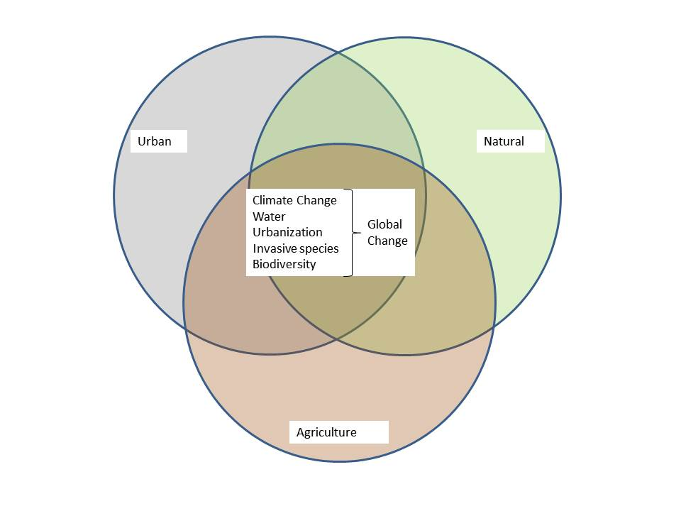

*Figure 4.* Overall framework of the 5 identified focus areas interacting with agricultural, urban and natural systems.

**Capacity and strengths**

* Existing Applied Biodiversity Science (ABS) IGERT
  + Expand with environment and sustainability component
  + Potential blueprint for new IGERT
* Interdisciplinary research program in Ecology and Evolutionary Biology (EEB) provides collaborative platform and capacity to lead efforts in this area
* Extensive international expertise within college, for example through the Borlaug Center and USAID Higher Education Solutions Network.
* Experienced teams already present within the Texas Water Resources Institute (TWRI), Institute for Renewable Natural Resources (IRNR) and Water Management and Hydrologic Science Program
* Large number of faculty working on water related issues, some on climate change. Overall diversity of research skills in college provides experts in almost any critical issue facing the environment, for example
  + Stream health and restoration
  + Marine dead zones
  + Invasive species
  + Habitat fragmentation
  + Biodiversity losses
  + Saltwater intrusion
  + Pollution
  + Wetland ecology and restoration
  + Deforestation and reduced forest health
  + Plant and animal disease
  + Seasonal drought and impacts of rising temperatures

**Outcomes and Goals**

* New IGERT, for example:
  + Drought impacts and mitigation
  + Sustainable water management
  + Impacts and mitigation of land use change
  + Biological consequences of climate change
* Become competitive for large federal grants within the focus areas
* A research center for global change research in collaboration with the Texas Center for Climate Studies in Geosciences where the new research center would focus on the biological/soils/water and nutrient cycling components of global change
* A center for “sustainable solutions”, e.g., joined with Landscape Architecture and Urban Development focusing on green urban development, innovative sustainable agriculture, bioenergy
* Broad financial support from federal, state and private sources (e.g., foundations such as the East Foundation)
* Establish an NSF-LTER site in Texas focused on “managed ecosystems”

**Strategic Needs to Accomplish Outcomes and Goals**

* Internationally recognized leader(s) in climate change/sustainability research needed to attract level of funding necessary to support a center
* Connections with private foundations to clarify how this research will meet the need of private landowners
* Improved research infrastructure to support and strengthen current research
* Faculty than can lead modeling efforts to tie current faculty research together
* Increased research strength into responses of animals to climate and land use change (e.g., range shifts in responses to increased climate variability)